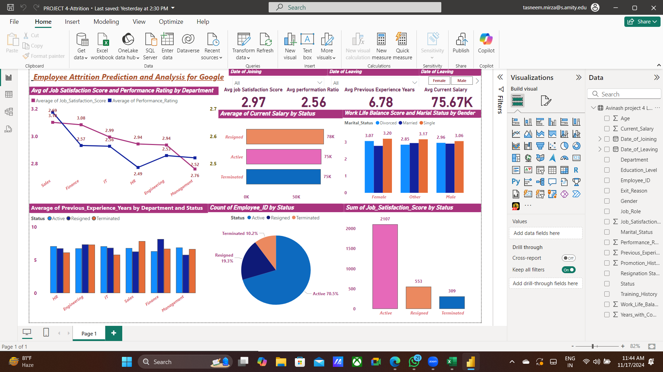

This dashboard provides an **Employee Attrition Analysis** for Google, focusing on key metrics to understand employee turnover trends and their underlying causes. Here's a breakdown:

1. **Average Job Satisfaction Score and Performance Rating by Department**: Displays how job satisfaction and performance ratings vary across departments like Sales, IT, HR, etc., highlighting potential areas of concern.
2. **Summary Statistics**:
   * **Average Job Satisfaction Score**: 2.97.
   * **Average Performance Rating**: 2.56.
   * **Average Previous Experience Years**: 6.78 years.
   * **Average Current Salary**: ₹75.67K (categorized by employee status such as Active, Resigned, and Terminated).
3. **Salary and Work-Life Balance by Gender**:
   * Comparison of average salaries across statuses.
   * Work-life balance scores split by marital status and gender.
4. **Experience and Status Distribution**:
   * Bar chart comparing the average years of previous experience across departments for Active, Resigned, and Terminated employees.
   * Pie chart showing the distribution of employee statuses: 70.5% Active, 19.3% Resigned, and 10.2% Terminated.
5. **Job Satisfaction by Status**: Highlights the total job satisfaction scores for employees based on their current status (Active, Resigned, or Terminated).

**Key Insights:**

* Departments like HR and Engineering have relatively low satisfaction and performance scores.
* Resigned employees have slightly higher salaries but lower satisfaction compared to active employees.
* Work-life balance varies across genders and marital statuses, potentially impacting attrition rates.

The dashboard enables HR teams to identify trends, address issues, and improve retention strategies.